Git clone and push ;

Git init
Git clone <your repo>

Push ;
Git add <application name>
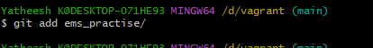

Git commit
Git commit -m <file added>
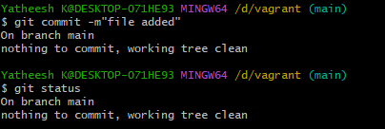
Git remove remote origin
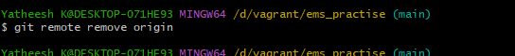
Git remote add origin <your origin url>
Git branch -m main
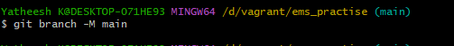
Git push -u origin main
